New release

Faster and larger capacity than ever

Seika Studio II Braille Computer

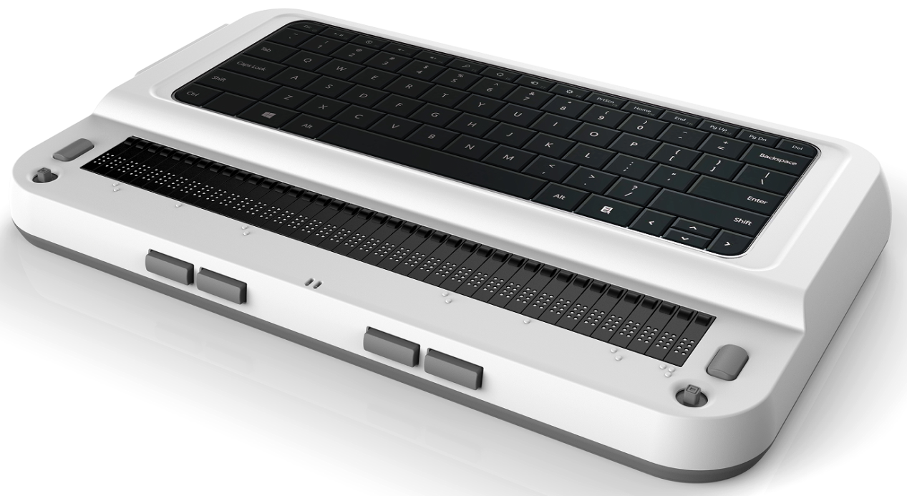

The Seika Studio II is a portable 40 cells Braille computer with the Microsoft Windows OS. You can install yours prefer screen reader and you can do everything which your laptop can do.
The Seika Studio total weight is 1.6 kg with dimensions of 12.6 (W) x 7.6 (D) x 2.0 (H) inches.

- CPU: Intel Core 3 100U (6-Cores, 8-Threads) or above
- Support DDR5 RAM 16GB or above
- Support NVMe SSD 1TB or above
- Supports HID standard for Braille display. You do not need install any driver or patch in the screen reader, you can connect Seika Studio II directly by Bluetooth and USB with screen reader which support braille HID
- Bluetooth and USB speaker: can work as a Bluetooth and USB speaker working with Smartphone and PC/Mac/iPad Smartphone Controller:
- can work as Bluetooth keyboard and you can control your Smartphone freely. Enjoy keeping your Smartphone in your pocket and controlling it by Seika Studio II
- 1x USB-C slot, support data transfer and USB PD quick charger
- 1x Thunderbolt USB-C slot, support USB4 and DisplayPort DP 1.4a
- Bluetooth and USB HID QWERTY keyboard, Braille keyboard by using asdfjkl;
- Wireless: Wi-Fi 6E and Bluetooth v5.3
- Wall adapter DC IN socket
- USB 2.0 and USB 3.0 Host socket
- Headphone jack
- HDMI output socket
- Internal Speaker and Mic-phone
- Braille display: 40 refreshable 8-Dot Braille cells
- Braille buttons and 40 routing-keys
- Rechargeable battery
Nippon Telesoft Co., ltd.
3F,2-1-3, Momoi, Suginami-ku,
Tokyo 167-0034 Japan
Email; ts-info@telesoft.co.jp
http;//www.nippontelesoft.com

