Seika Plus II –Smart Notetaker
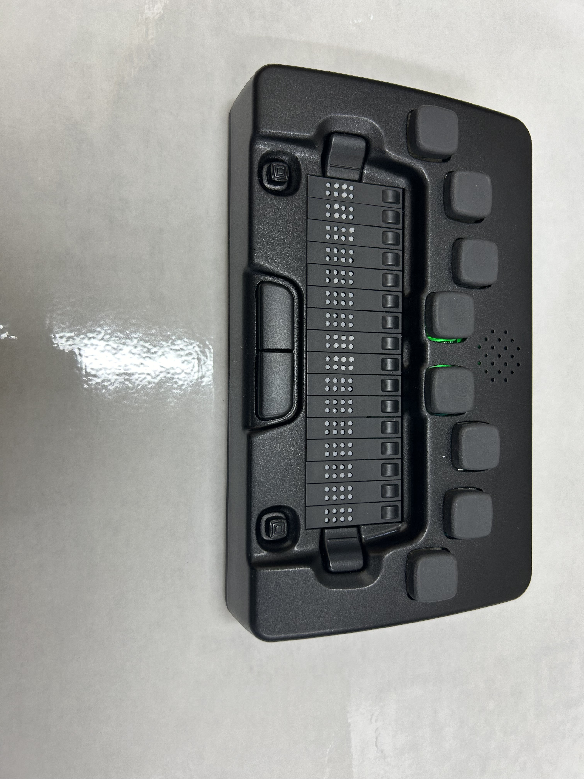
We will launch a new product- Seika Plus II Smart Notetaker which is new designed notetaker Braille display, runs Android OS and supports install third party Android apps. The Seika Plus 2 also supports connect with other device as a Braille display by using USB cable and Bluetooth, supports Android phone and tablet, iPhone and iPad, Windows PC, Mac.
Newest Seika Smart Braille® features:
- Supports HID standard for Braille display: so you do not need install driver or patch in the screen reader, you can connect Plus II directly by Bluetooth and USB with screen reader which support braille HID
- Bluetooth and USB headset & speaker: PlusII can work as a Bluetooth and USB headset & speaker working with Smartphone and PC/Mac/iPad, listen from and speak to those devices easily.
- Smartphone Controller: Plus II can work as Bluetooth keyboard and you can control your Smartphone freely. Enjoy keeping your Smartphone in your pocket and controlling it by Seika Studio II.
Specification;
- 16,or 24 cells 8 dots refreshable Braille display
- 8-dots Braille keyboard with space buttons
- Qwerty keyboard (only Seika 40 Plus 2)
- Function buttons and routing buttons
- CPU: Qualcomm ARM Quad-cores, 2.0 GHz
- 4 GB RAM, 64 GB storage
- Android 13 OS
- 4G cell phone call and mobile data access
- WiFi 2.4 & 5 GHz 802.11 a/b/g/n/ac Bluetooth v5.0 EDR+BLE
- USB-A host socket, external TF card, SIM card, internal TF card
- USB-C device socket
- Mini-HDMI output
- Internal Speaker and microphone
- Headset socket
- Rechargeable Li-battery
- Supports the Seika Smart Braille display features: as a Braille display by using USB cable and Bluetooth
- Multi-language TTS speech
- Build-in file manager, word, outlook, email, web browser, media player, calendar, contact apps
- The Seika BraillePlus app
- Supports install third party Android apps

Please feel free to contact us.

Nippon Telesoft Co.,Ltd.
ts-info@telesoft.co.jp
http://www.nippontelesoft.com
3F, 2-1-3,Momoi, Suginami-ku,
Tokyo 167-0034 Japan
Phone:+81-3-6913-5641
FAX:+81-3-6913-5977

